Making Christ Known
October 4, 2026
Prelude Mrs. Betsy Jordan
Welcome
Scripture Reading & Prayer
Hymn 527 “Glory To His Name”
Hymn 185 “When I Survey the Wondrous Cross”

Offertory Mrs. Kimberly Newsome

Special Music Adult Choir

Hymn of the Month “Only a Holy God”

Message “Come to the Table of the King”
1 Corinthians 11:23-26
Rev. Randy Shrum

The Apostles Creed Page 716

The Lord’s Table

Hymn 625 “Doxology”

Ingathering

Our 63rd Annual Ingathering will be on Saturday, October 31st. The meal will be at noon. Get your items ready for the auction. Invite your families and friends.

We welcome our visitors this morning. It is our sincere hope that you feel welcome, that you will be aware of our Lord’s presence, and that you will desire to worship with us again.

The beautiful flowers in the Sanctuary are given to the glory of God by Mrs. Deb Osborne.

Events for the Week
Today Sunday School 10:00 am
Morning Worship (The Lord’s Table) 11:00 am
Covered dish lunch 12:00 pm
Adult Choir Practice 5:00 pm
Evening Worship 6:00 pm
Missions Committee Meeting 7:15 pm
Tuesday Board of Stewards in Fellowship Hall 7:00 pm
Wednesday WGE Prayer on the Playground 7:30 am
Prayer Services 6:30 pm
Friday Sixty Plus Fellowship @ Becky’s Café 11:30 am
Girl’s Fall Fellowship 6:00-8:00 pm

Coming Events
Oct.16-18 (F-S) Mountain Colors Retreat at 3 Forks
Oct. 18th (Sun) Youth Committee Meeting 4:30 pm
Oct. 19th (Mon) TWMS in CCLC Building 6:30 pm
District Men’s Cartwright Fellowship 7:00 pm
Oct. 25th (Sun) Shower for Jeb Green & Kathryn Level 3:00 – 4:30 pm
Oct. 31st (Sat) Ingathering 12:00 pm

Bible Conference will be November 1st through 4th with Rev. Gowdy Cannon as our speaker. Make your plans now to attend.

Girl’s Fall Fellowship
October 9th in the Fellowship Hall 6:00-8:00
We have pumpkins (Mr. Neal grew them for us!) to decorate, will have dinner and fellowship together.
Questions to Melissa Lynch 803-968-2996

Please feel free to call the Pastor for updates.

Prayer Concerns: April Green, Teri O’Neal, Lynn Dukes, Sandra Barrineau, Ginger & Kenny Keels, Billy Moore, Kathryn Chowning, Tommy, Nancy & Todd Morris, Alice Robinson, Tommy Kemp, Randy & Dannie Faye Osborne, Herbert & Linda Mims, Jimmy & Ruth Watts, Sarah Timmons, Riley & Taylor Goff & baby, Larry Logan, Rev. Pat Goodwin, Donnie Green, David Jordan, Stephanie & Cierra Carver, Robert Myers, Maxie & Sarah Knowlton, Roger Nesbitt, Timmy Thigpen & family, Jeffrey Osborne, Howell Myers, Travis Atkinson, Drew Dukes, Gerald & Joanne McElveen, Johnny McLaughlin, Dennis McElveen, Anthea Love, Kathryn Turbeville, Military, our church.

Serving as Missionaries: Gary & Penny Siethel, Yiannakis & Sheri Tittirus, Donna Crane

Shut-Ins & Caregivers: Larry & Jane Coker, Vera Mae Coker, Randy & Velma Floyd, Stanley Gibbons, Linda Green, Si Green, Carol Ann Griffith, Donna Mae Hardy, Nancy McFaddin, Adam Moore, Carolyn Walker, Mary Lee Wingard, Randy Wingard, Phyllis Yates.

Notes:

______________________________________

______________________________________
____________________________________________________________________________

Board of Stewards for October: George Green, John Hardy, Kurt Jordan

Turbeville Southern Methodist Church
Rev. Randy Shrum, Pastor

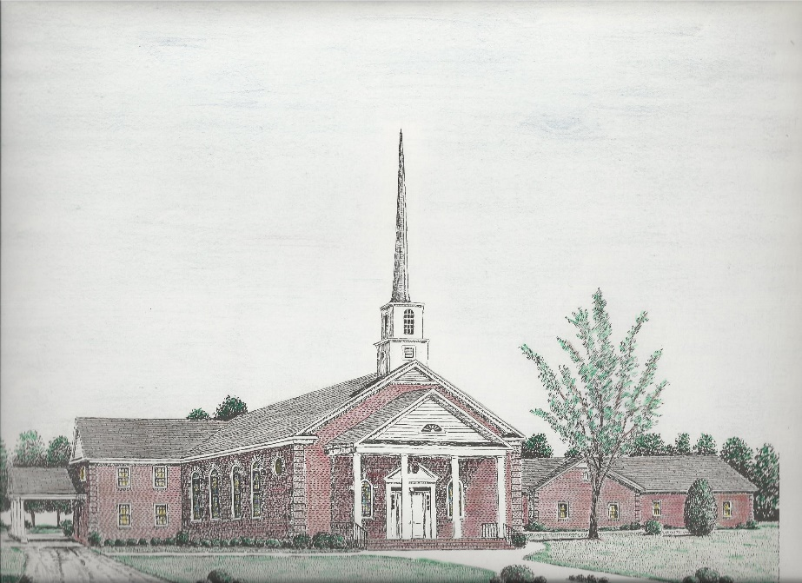

“Until the Whole World Knows”
“Across the Street and Across the Sea – Sent to Sow & Serve”

Our Vision: changing lives by faithfully and intentionally
sharing Christ’s salvation to all the world.

Our Mission …
to reach the lost; to provide spiritual fellowship for the saved; to promote spiritual growth of the saved; and to assist in sending the Gospel of Jesus Christ to the four corners of the earth.

Church Office Telephone: 843-659-2311
Mailing Address: 1642 Main Street, PO Box 233
Turbeville, SC 29162
E-mail Address: TSMChurch@outlook.com
Pastor’s Email: shrum1981@gmail.com
Pastor’s Cell Phone: 573-579-6798
Beth’s Cell Phone: 573-576-7577
Pastor’s Address: 1256 Pope St, Turbeville
Website: tsmc.church

