Making Christ Known
October 25, 2026
Prelude Mrs. Kimberly Newsome
Welcome
Scripture Reading & Prayer
Hymn 2 “Come, Thou Fount of Every Blessing”
Hymn 103 “Blessed Be the Name”

Offertory Mrs. Betsy Jordan

Special Music Adult Choir

Hymn of the Month “Only a Holy God”

Message “Believers Assurance”
1 John 2:1-14 Rev. Randy Shrum

Hymn 625 “Doxology”

Ingathering

Our 63rd Annual Ingathering will be on Saturday, October 31st. The meal will be at noon. BBQ bags will be sold for $25 per bag. If you want any, let the office know. The committees list has been mailed. Get your items ready for the auction. Invite your families and friends.

It’s time to order Poinsettias. They are $15.00 each. Order needs to be turned in no later than today, Sunday, October 25th. The order has to be placed tomorrow. You may purchase one poinsettia in memory or in honor of more than one person if you wish to do so. Just indicate that on your order form. Give the order form and money to Fran Moore. You may also email me at fwmoore@ftc-i.net or text me at 843-659-7941.

We welcome our visitors this morning. It is our sincere hope that you feel welcome, that you will be aware of our Lord’s presence, and that you will desire to worship with us again.

The beautiful flowers in the Sanctuary are given to the glory of God by Mrs. Sarah Green.

Events for the Week
Today Sunday School 10:00 am
Morning Worship 11:00 am
Shower for Jeb Green & Kathryn Level 3:00 pm-4:30 pm
Adult Choir Practice 5:00 pm
Christmas Play Practice 6:00 pm
Evening Worship 6:00 pm
Wednesday Bible Studies (Hebrews 13) 6:30 pm
Saturday Ingathering 12:00 pm

Coming Events
Nov.1-4 (S-W) WMS Week of Prayer
Bible Conference with Rev. Gowdy Cannon
Missions Committee Meeting 7:15 pm
Nov. 4th (Wed) WGE Prayer on the Playground 7:30 am
Nov. 7th (Sat) Friends of Camp Day @ Camp S & M 10:00 am
Nov. 8th (Sun) Evening Service -Night of Rememberance 6:00 pm
Nov. 10th (Tue) Board of Stewards in Fellowship Hall 7:00 pm
Nov. 11th (Wed) Veteran’s Day
Nov. 13th (Fri) Sixty Plus Fellowship @ Becky’s Café 11:30 am
Nov. 15th (Sun) Youth Committee Meeting 4:30 pm
Nov. 16th (Mon) TWMS in CCLC Building 6:30 pm
Nov. 23rd (Mon) Youth to Billy Graham Library
Nov. 26th (Thu) Thanksgiving Program 8:00 am
Nov. 29th (Sun) Benevolent Offering 11:00 am

Bible Conference will be November 1st through 4th with Rev. Gowdy Cannon as our speaker. Make your plans now to attend. WMS will host their week of prayer a half hour before the service.

Operation Christmas Child Warehouse Trip will be on Monday, November 23rd. If you would like to go, contact Shad: shadrach0506@gmail.com or 843-550-0205. Slots are filling up.

Please feel free to call the Pastor for updates.

Prayer Concerns: Nebo Cannon, Kat Coker, Sondra Floyd, April Green, Teri O’Neal, Sandra Barrineau, Ginger & Kenny Keels, Billy Moore, Kathryn Chowning, Tommy, Nancy & Todd Morris, Alice Robinson, Tommy Kemp, Randy & Dannie Faye Osborne, Herbert & Linda Mims, Jimmy & Ruth Watts, Sarah Timmons, Riley & Taylor Goff & baby, Larry Logan, Rev. Pat Goodwin, David Jordan, Stephanie & Cierra Carver, Robert Myers, Maxie & Sarah Knowlton, Roger Nesbitt, Timmy Thigpen & family, Jeffrey Osborne, Howell Myers, Travis Atkinson, Drew Dukes, Gerald & Joanne McElveen, Johnny McLaughlin, Jan Conyers, Anthea Love, Kathryn Turbeville, Mike Ward, Lisel, Military, our church, family of Crafton Cannon.

Serving as Missionaries: Steve & Beth Coffee, John & Brena Bruner, Rod & Julie Davis, Jimmy & Roxanne Cox, Ray & Paula Yoder.

Shut-Ins & Caregivers: Larry & Jane Coker, Vera Mae Coker, Randy & Velma Floyd, Stanley Gibbons, Linda Green, Si Green, Carol Ann Griffith, Donna Mae Hardy, Nancy McFaddin, Adam Moore, Carolyn Walker, Mary Lee Wingard, Randy Wingard, Phyllis Yates.

Notes:

______________________________________

______________________________________
____________________________________________________________________________

Board of Stewards for October: George Green, John Hardy, Kurt Jordan
Board of Stewards for November: Grey Coker, Scott Green, Billy Moore
Turbeville Southern Methodist Church
Rev. Randy Shrum, Pastor

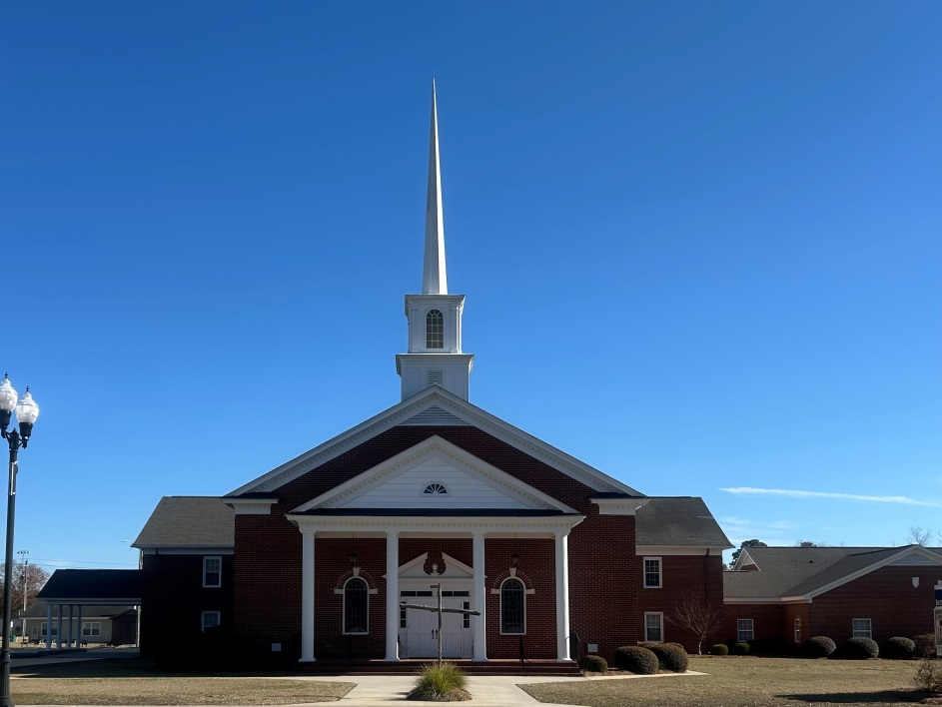

“Until the Whole World Knows”
“Across the Street and Across the Sea – Sent to Sow & Serve”

Our Vision: changing lives by faithfully and intentionally
sharing Christ’s salvation to all the world.

Our Mission …
to reach the lost; to provide spiritual fellowship for the saved; to promote spiritual growth of the saved; and to assist in sending the Gospel of Jesus Christ to the four corners of the earth.

Church Office Telephone: 843-659-2311
Mailing Address: 1642 Main Street, PO Box 233
Turbeville, SC 29162
E-mail Address: TSMChurch@outlook.com
Pastor’s Email: shrum1981@gmail.com
Pastor’s Cell Phone: 573-579-6798
Beth’s Cell Phone: 573-576-7577
Pastor’s Address: 1256 Pope St, Turbeville
Website: tsmc.church

