Making Christ Known
October 11, 2026
Prelude Mrs. Kimberly Newsome
Welcome
Scripture Reading & Prayer
Hymn 588 “We Have Come into His House”
Hymn 451 “O Master, Let Me Walk with Thee”

Offertory Mrs. Betsy Jordan

Special Music Women’s Choir

Hymn of the Month “Only a Holy God”

Message “Finally!” The Conclusion of the Whole Matter
Ecclesiastes 12 Rev. Randy Shrum

Hymn 625 “Doxology”

Ingathering

Our 63rd Annual Ingathering will be on Saturday, October 31st. The meal will be at noon. The committees list has been mailed. Get your items ready for the auction. Invite your families and friends.

We welcome our visitors this morning. It is our sincere hope that you feel welcome, that you will be aware of our Lord’s presence, and that you will desire to worship with us again.

The beautiful flowers in the Sanctuary are given to the glory of God by Mrs. Betsy Jordan in memory of Earl Bradham Coker.

Events for the Week
Today Sunday School 10:00 am
Morning Worship 11:00 am
Adult Choir Practice 5:00 pm
Evening Worship 6:00 pm
Wednesday Prayer Services 6:30 pm
Friday-Sun Mountain Colors Retreat at 3 Forks

Coming Events
Oct. 18th (Sun) Youth Committee Meeting 4:30 pm
Oct. 19th (Mon) TWMS in CCLC Building 6:30 pm
District Men’s Cartwright Fellowship 7:00 pm
Oct. 25th (Sun) Shower for Jeb Green & Kathryn Level 3:00 – 4:30 pm
Oct. 31st (Sat) Ingathering 12:00 pm

Bible Conference will be November 1st through 4th with Rev. Gowdy Cannon as our speaker. Make your plans now to attend.

Cartwright Men’s Fellowship will be here at TSMC on Monday, October 19th at 7 pm. Men, mark your calendars and bring a friend.

Operation Christmas Child Warehouse Trip will be on Monday, November 23rd. If you would like to go, contact Shad: shadrach0506@gmail.com or 843-550-0205. Slots are filling up.

Please feel free to call the Pastor for updates.

Prayer Concerns: April Green, Teri O’Neal, Sandra Barrineau, Ginger & Kenny Keels, Billy Moore, Kathryn Chowning, Tommy, Nancy & Todd Morris, Alice Robinson, Tommy Kemp, Randy & Dannie Faye Osborne, Herbert & Linda Mims, Jimmy & Ruth Watts, Sarah Timmons, Riley & Taylor Goff & baby, Larry Logan, Rev. Pat Goodwin, David Jordan, Stephanie & Cierra Carver, Robert Myers, Maxie & Sarah Knowlton, Roger Nesbitt, Timmy Thigpen & family, Jeffrey Osborne, Howell Myers, Travis Atkinson, Drew Dukes, Gerald & Joanne McElveen, Johnny McLaughlin, Jan Conyers, Anthea Love, Kathryn Turbeville, Military, our church, family of Donnie Green.

Serving as Missionaries: CCLC, Area Pastors & Families, Lost in the Community

Shut-Ins & Caregivers: Larry & Jane Coker, Vera Mae Coker, Randy & Velma Floyd, Stanley Gibbons, Linda Green, Si Green, Carol Ann Griffith, Donna Mae Hardy, Nancy McFaddin, Adam Moore, Carolyn Walker, Mary Lee Wingard, Randy Wingard, Phyllis Yates.

Notes:

______________________________________

______________________________________
____________________________________________________________________________

Board of Stewards for October: George Green, John Hardy, Kurt Jordan

Turbeville Southern Methodist Church
Rev. Randy Shrum, Pastor

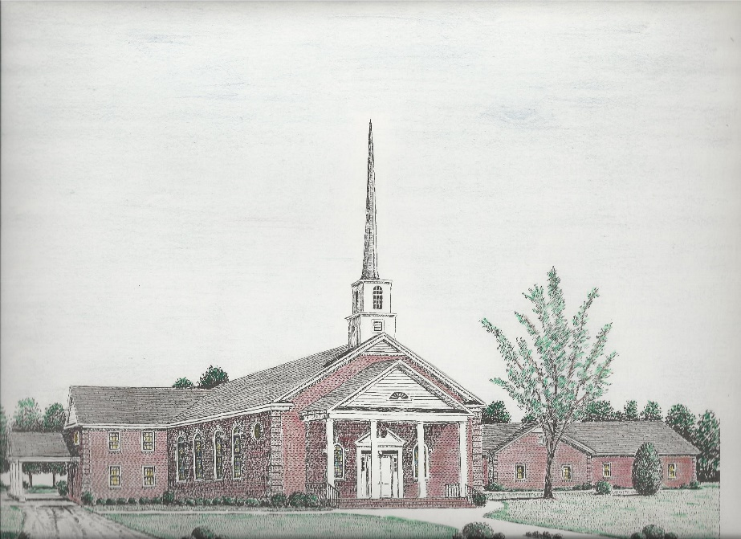

“Until the Whole World Knows”
“Across the Street and Across the Sea – Sent to Sow & Serve”

Our Vision: changing lives by faithfully and intentionally
sharing Christ’s salvation to all the world.

Our Mission …
to reach the lost; to provide spiritual fellowship for the saved; to promote spiritual growth of the saved; and to assist in sending the Gospel of Jesus Christ to the four corners of the earth.

Church Office Telephone: 843-659-2311
Mailing Address: 1642 Main Street, PO Box 233
Turbeville, SC 29162
E-mail Address: TSMChurch@outlook.com
Pastor’s Email: shrum1981@gmail.com
Pastor’s Cell Phone: 573-579-6798
Beth’s Cell Phone: 573-576-7577
Pastor’s Address: 1256 Pope St, Turbeville
Website: tsmc.church

