Making Christ Known
September 20, 2026
Prelude Mrs. Betsy Jordan
Welcome
Scripture Reading & Prayer
Hymn 380 “Just a Closer Walk with Thee”
Hymn 382 “Be Thou My Vision”

Offertory Mrs. Kimberly Newsome

Special Music Adult Choir

Hymn of the Month 25 “Immortal, Invisible”

Message “Generational Legacy”
1 Timothy 1:1-7
Rev. Randy Shrum

Hymn 625 “Doxology”

We welcome our visitors this morning. It is our sincere hope that you feel welcome, that you will be aware of our Lord’s presence, and that you will desire to worship with us again.

The beautiful flowers in the Sanctuary are given to the glory of God by Mrs. Beth Welch.

Events for the Week
Today Sunday School 10:00 am
Morning Worship 11:00 am
Shower for Alex O’Neal & Taylor Tanner 3:00-4:30 pm
Adult Choir Practice 5:00 pm
Evening Worship 6:00 pm
Monday TWMS in CCLC Building 6:30 pm
Tuesday Autumn Begins
Wednesday Bible Studies 6:30 pm
Saturday Legacy Grandparenting Summit 9 am–4:30 pm

Coming Events
Sept. 27th (Sun) Youth Committee Meeting 4:30 pm
Oct. 4th (Sun) Communion 11:00 am
Oct. 4th (Sun) Missions Committee Meeting 7:15 pm
Oct. 6th (Tue) Board of Stewards in Fellowship Hall 7:00 pm
Oct. 7th (Wed) WGE Prayer on the Playground 7:30 am
Oct.16-18 (F-S) Mountain Colors Retreat at 3 Forks
Oct. 18th (Sun) Youth Committee Meeting 4:30 pm
Oct. 20th (Mon) TWMS in CCLC Building 6:30 pm
District Men’s Cartwright Fellowship 7:00 pm
Oct. 25th (Sun) Shower for Jeb Green & Kathryn 3:00 – 4:30 pm

Please feel free to call the Pastor for updates.

Prayer Concerns: Lynn Dukes, Sandra Barrineau, Ginger & Kenny Keels, Chad Bartlett, Billy Moore, Tommy, Nancy & Todd Morris, Alice Robinson, Frank White, Tommy Kemp, Randy & Dannie Faye Osborne, Taylor Moore, Herbert & Linda Mims, Ruth Watts, Sarah Timmons, Riley & Taylor Goff & baby, Larry Logan, Rev. Pat Goodwin, Donnie Green, David Jordan, Stephanie & Cierra Carver, Steven Muldrow, Maxie & Sarah Knowlton, Roger Nesbitt, Timmy Thigpen & family, Jeffrey Osborne, Howell Myers, Travis Atkinson, Drew Dukes, Gerald & Joanne McElveen, Johnny McLaughlin, Dennis McElveen, Dusty Ward, Anthea Love, Kathryn Turbeville, Military, our church, family of Junior Hopkins (crop duster pilot), family of Rev. Frank McLellan.

Serving as Missionaries: Steve & Beth Coffee, John & Brena Bruner, Rod & Julie Davis, Jimmy & Roxanne Cox, Ray & Paula Yoder.

Shut-Ins & Caregivers: Larry & Jane Coker, Vera Mae Coker, Randy & Velma Floyd, Stanley Gibbons, Linda Green, Si Green, Carol Ann Griffith, Donna Mae Hardy, Nancy McFaddin, Adam Moore, Carolyn Walker, Roy & Margarite Walker, Mary Lee Wingard, Randy Wingard, Phyllis Yates.

Notes:

______________________________________

______________________________________
____________________________________________________________________________

Board of Stewards for September : Kurt Jordan, Jason Newsome, Glynn Webster

Turbeville Southern Methodist Church
Rev. Randy Shrum, Pastor

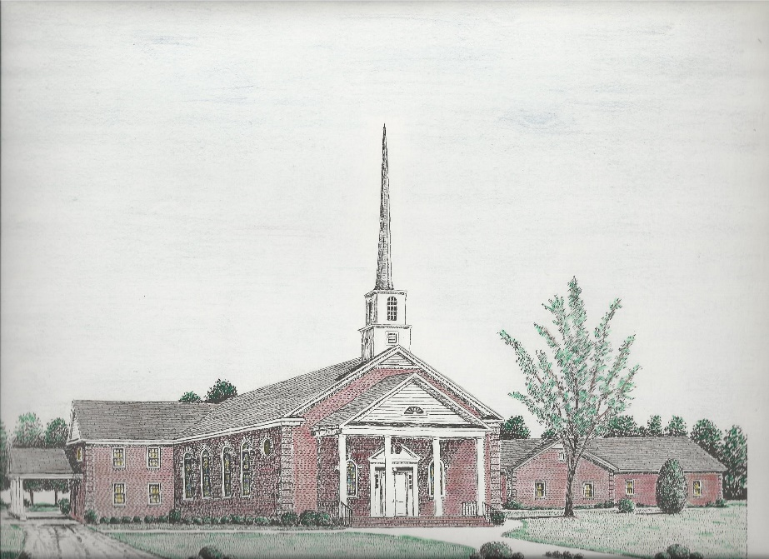

“Until the Whole World Knows”
“Across the Street and Across the Sea – Sent to Sow & Serve”

Our Vision: changing lives by faithfully and intentionally
sharing Christ’s salvation to all the world.

Our Mission …
to reach the lost; to provide spiritual fellowship for the saved; to promote spiritual growth of the saved; and to assist in sending the Gospel of Jesus Christ to the four corners of the earth.

Church Office Telephone: 843-659-2311
Mailing Address: 1642 Main Street, PO Box 233
Turbeville, SC 29162
E-mail Address: TSMChurch@outlook.com
Pastor’s Email: shrum1981@gmail.com
Pastor’s Cell Phone: 573-579-6798
Beth’s Cell Phone: 573-576-7577
Pastor’s Address: 1256 Pope St, Turbeville
Website: tsmc.church

