Making Christ Known
September 13, 2026
Prelude Mrs. Kimberly Newsome
Welcome
Scripture Reading & Prayer
Hymn 409 “I Know Whom I Have Believed”
Hymn 463 Accapella “Precious Lord, Take My Hand”

Offertory Mrs. Betsy Jordan

Special Music Mrs. Amy Glover

Hymn of the Month 25 “Immortal, Invisible”

Message “Wisdom for Living in a Fallen World”
Ecclesiastes 7:1-12:8
Rev. Randy Shrum

Hymn 625 “Doxology”

We welcome our visitors this morning. It is our sincere hope that you feel welcome, that you will be aware of our Lord’s presence, and that you will desire to worship with us again.

The beautiful flowers in the Sanctuary are given to the glory of God in memory of JC & Ann Watts by their children.

Events for the Week
Today Sunday School 10:00 am
Morning Worship 11:00 am
Adult Choir Practice 5:00 pm
Evening Worship 6:00 pm
Thursday Ribbon Cutting @ The Well at Turbeville 6:00 pm

Coming Events
Sept. 20th (Sun) Shower for Alex O’Neal & Taylor Tanner 3:00-4:40 pm
Youth Committee Meeting 4:30 pm
Sept. 21st (Mon) TWMS in CCLC Building 6:30 pm
Sept. 22nd (Tue) Autumn Begins
Sept. 26th (Sat) Legacy Grandparenting Summit 9am-4:30pm

You are invited to the Ribbon Cutting and Open House at “The Well at Turbeville”. Thursday, September 17th at 6 pm – 1292 Green Street, Turbeville. This ministry is to help families with food pantry, free boutique, Beds of Hope and other outreach opportunities.

Please feel free to call the Pastor for updates.

Prayer Concerns: Shay Hall, Gwenn Lee, Lynn Dukes, Sandra Barrineau, Ginger & Kenny Keels, Chad Bartlett, Billy Moore, Tommy, Nancy & Todd Morris, Alice Robinson, Frank White, Tommy Kemp, Randy & Dannie Faye Osborne, Taylor Moore, Herbert & Linda Mims, Ruth Watts, Sarah Timmons, Riley & Taylor Goff & baby, Larry Logan, Rev. Pat Goodwin, Donnie Green, David Jordan, Stephanie & Cierra Carver, Steven Muldrow, Maxie & Sarah Knowlton, Roger Nesbitt, Timmy Thigpen & family, Jeffrey Osborne, Howell Myers, Travis Atkinson, Drew Dukes, Gerald & Joanne McElveen, Johnny McLaughlin, Dennis McElveen, Dusty Ward, Anthea Love, Military.

Serving as Missionaries: Teen Missions International, Trey & Mary Watts, Brant & Mary Lane, Steve & Gay Petersen, Rodney & Teresa Walls, Dale & LyNan Redman.

Shut-Ins & Caregivers: Larry & Jane Coker, Vera Mae Coker, Randy & Velma Floyd, Stanley Gibbons, Linda Green, Si Green, Carol Ann Griffith, Donna Mae Hardy, Nancy McFaddin, Adam Moore, Carolyn Walker, Roy & Margarite Walker, Mary Lee Wingard, Randy Wingard, Phyllis Yates.

Notes:

______________________________________

______________________________________
____________________________________________________________________________

Board of Stewards for September : Kurt Jordan, Jason Newsome, Glynn Webster

Turbeville Southern Methodist Church
Rev. Randy Shrum, Pastor

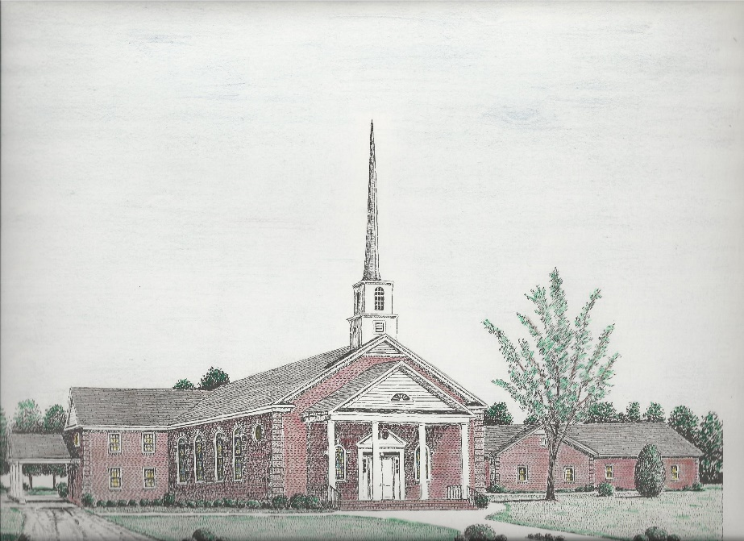

“Until the Whole World Knows”
“Across the Street and Across the Sea – Sent to Sow & Serve”

Our Vision: changing lives by faithfully and intentionally
sharing Christ’s salvation to all the world.

Our Mission …
to reach the lost; to provide spiritual fellowship for the saved; to promote spiritual growth of the saved; and to assist in sending the Gospel of Jesus Christ to the four corners of the earth.

Church Office Telephone: 843-659-2311
Mailing Address: 1642 Main Street, PO Box 233
Turbeville, SC 29162
E-mail Address: TSMChurch@outlook.com
Pastor’s Email: shrum1981@gmail.com
Pastor’s Cell Phone: 573-579-6798
Beth’s Cell Phone: 573-576-7577
Pastor’s Address: 1256 Pope St, Turbeville
Website: tsmc.church

