Making Christ Known
August 30, 2026
Prelude Mrs. Kimberly Newsome
Welcome
Scripture Reading & Prayer
Hymn 470 “Footsteps of Jesus”

Hymn 458 “Gentle Shepherd”

Offertory Mrs. Betsy Jordan

Special Music Adult Choir

Hymn of the Month “Christ, the True and Better”

Hymn 332 “Without Him”

Message “Frustrations of Life Under the Sun”
Ecclesiastes 4:1-6:12 Rev. Randy Shrum

Local Conference for Nominations

Hymn 625 “Doxology”

We welcome our visitors this morning. It is our sincere hope that you feel welcome, that you will be aware of our Lord’s presence, and that you will desire to worship with us again.

The beautiful flowers in the Sanctuary are given to the glory of God by Mrs. Dannie Faye Osborne in memory of Chris & Tony McLaughlin.

Events for the Week
Today Sunday School (SS Vision Presentation) 10:00 am
Morning Worship (Benevolent Offering) 11:00 am
Music Committee Meeting 5:00 pm
5th Sunday Hymn Sing Service 6:00 pm
Tuesday Prayer on the Playground 7:30 am
Wednesday Bible Studies (Hebrews 12) 6:30 pm

Coming Events
Sept. 7th (Mon) Labor Day
Sept. 8th (Tue) Board of Stewards in Fellowship Hall 7:00 pm
Sept. 9th (Wed) Missions Committee Meeting 7:30 pm
Sept. 11th (Fri) Sixty Plus Fellowship @ Becky’s café 11:30 am
Sept. 11-13(F-S) Eastern Conference WMS Retreat
Sept. 17th (Thu) Ribbon Cutting @ The Well at Turbeville 6:00 pm
Sept. 20th (Sun) Youth Committee Meeting 4:30 pm
Sept. 21st (Mon) TWMS in CCLC Building 6:30 pm
Sept. 22nd (Tue) Autumn Begins

You are invited to the Ribbon Cutting and Open House at “The Well at Turbeville”. Thursday, September 17th at 6 pm – 1292 Green Street, Turbeville. This ministry is to help families with food pantry, free boutique, Beds of Hope and other outreach.

Please feel free to call the Pastor for updates.

Prayer Concerns: Shay Hall, Gwenn Lee, Lynn Dukes, Sandra Barrineau, Ginger & Kenny Keels, Chad Bartlett, Billy Moore, Tommy, Nancy & Todd Morris, Alice Robinson, Frank White, Tommy Kemp, Randy & Dannie Faye Osborne, Taylor Moore, Herbert & Linda Mims, Ruth Watts, Sarah Timmons, Riley & Taylor Goff & baby, Larry Logan, Rev. Pat Goodwin, Donnie Green, David Jordan, Stephanie & Cierra Carver, Steven Muldrow, Maxie & Sarah Knowlton, Roger Nesbitt, Timmy Thigpen & family, Jeffrey Osborne, Howell Myers, Travis Atkinson, Drew Dukes, Gerald & Joanne McElveen, Johnny McLaughlin, Dennis McElveen, Dusty Ward, Anthea Love, Military, family of Myrtle Gibbons.

Serving as Missionaries: Gary & Penny Siethel, Yiannakis & Sheri Tittirus,
Donna Crane

Shut-Ins & Caregivers: Larry & Jane Coker, Vera Mae Coker, Randy & Velma Floyd, Stanley Gibbons, Linda Green, Si Green, Carol Ann Griffith, Donna Mae Hardy, Nancy McFaddin, Adam Moore, Carolyn Walker, Roy & Margarite Walker, Mary Lee Wingard, Randy Wingard, Phyllis Yates.

Notes:

______________________________________

______________________________________
____________________________________________________________________________

Board of Stewards for August: John Hardy & Benny Knowlton

Turbeville Southern Methodist Church
Rev. Randy Shrum, Pastor

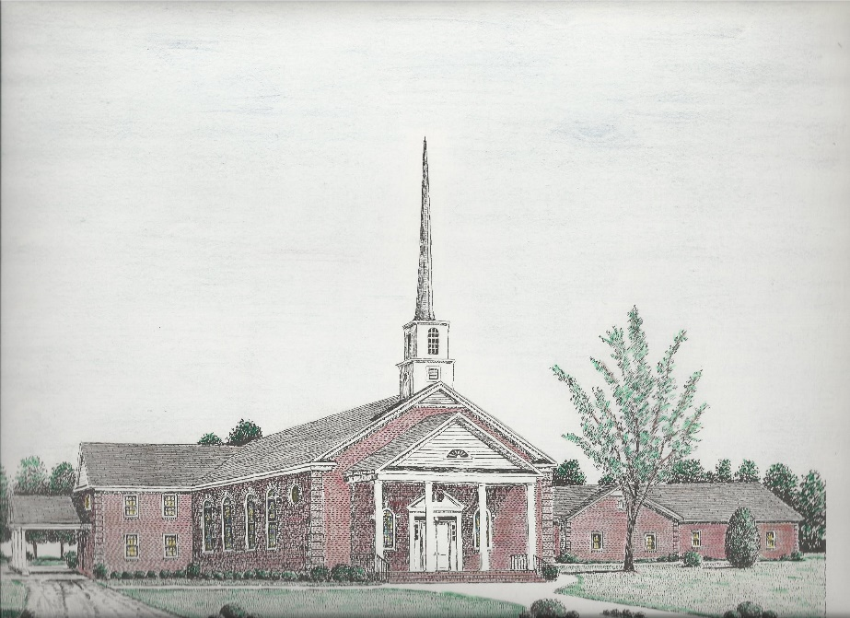

“Until the Whole World Knows”
“Across the Street and Across the Sea – Sent to Sow & Serve”

Our Vision: changing lives by faithfully and intentionally
sharing Christ’s salvation to all the world.

Our Mission …
to reach the lost; to provide spiritual fellowship for the saved; to promote spiritual growth of the saved; and to assist in sending the Gospel of Jesus Christ to the four corners of the earth.

Church Office Telephone: 843-659-2311
Mailing Address: 1642 Main Street, PO Box 233
Turbeville, SC 29162
E-mail Address: TSMChurch@outlook.com
Pastor’s Email: shrum1981@gmail.com
Pastor’s Cell Phone: 573-579-6798
Beth’s Cell Phone: 573-576-7577
Pastor’s Address: 1256 Pope St, Turbeville
Website: tsmc.church

