Making Christ Known
July 12, 2026

Prelude Mrs. Betsy Jordan
Welcome
Scripture Reading & Prayer
Special Music Men’s Choir

Hymn 201 “Grace Greater Than Our Sin”

Hymn “Almost Home”

Offertory Mrs. Kimberly Newsome

Hymn of the Month “Ancient of Days”

Message “A Beauty Contest”
Esther 1
Rev. Randy Shrum

Hymn 625 “Doxology”

We welcome our visitors this morning. It is our sincere hope that you feel welcome, that you will be aware of our Lord’s presence, and that you will desire to worship with us again.

The beautiful flowers in the Sanctuary are given to the glory of God by Ms. Irene Hardy.

The flag in the front of the sanctuary is to remind us to pray for Graham Newsome who is spending his summer serving on a church planting team in New York City.

Events for the Week
Today Sunday School 10:00 am
Morning Worship 11:00 am
The Great Awakening Movie – Part 1 5:30 pm
Wednesday Bible Studies 6:30 pm

Coming Events
July 19th (Sun) Retired Ministers Offering 11:00 am
Youth Committee Organizational Meeting 4:30 pm
The Great Awakening Movie – Part II 5:30 pm
July 20th (Mon) TWMS in CCLC Building 6:30 pm
District Cartwright @ Timmonsville 7:00 pm
July 22-24 Eastern Annual Conference in Monroe, NC

We will be showing the movie “The Great Awakening” tonight at 5:30 pm. Bring your favorite fun finger food for afterwards in the Fellowship Hall. Bring a friend!
Part 2 will be next week. Come join us!

Please feel free to call the Pastor for updates.

Prayer Concerns: Tommy Kemp, Dannie Faye Osborne, Taylor Moore, Herbert Mims, Wheeler McCallum, Billy Moore, Keith Jordan, Ruth Watts, April Green, Sarah Timmons, Wallace Green, Riley & Taylor Goff & baby, Scott Beasley, Larry Logan, Rev. Pat Goodwin, Kenny Keels, Richard Clowney, Donnie Green, April Graham, David Jordan, Stephanie & Cierra Carver, Steven Muldrow, Maxie & Sarah Knowlton, Roger Nesbitt, Timmy Thigpen & family, Jeffrey Osborne, Lois Gibbons, Travis Atkinson, Howell Myers, Christine Bryant, Drew Dukes, Joanne McElveen, Johnny McLaughlin, Ann Strickland, Wendy Barnhill, Dennis McElveen, Dusty Ward, Anthea Love, Military.

Serving as Missionaries: Steve & Anthea Love, Chris & Tami Harbin, Sam & Liz Bruner.

Shut-Ins & Caregivers: Alan Coker, Larry & Jane Coker, Vera Mae Coker, Randy & Velma Floyd, Stanley Gibbons, Linda Green, Si Green, Carol Ann Griffith, Donna Mae Hardy, Nancy McFaddin, Adam Moore, Carolyn Walker, Roy & Margarite Walker, Mary Lee Wingard, Randy Wingard, Phyllis Yates.

Notes:

______________________________________

______________________________________
____________________________________________________________________________

Turbeville Southern Methodist Church
Rev. Randy Shrum, Pastor

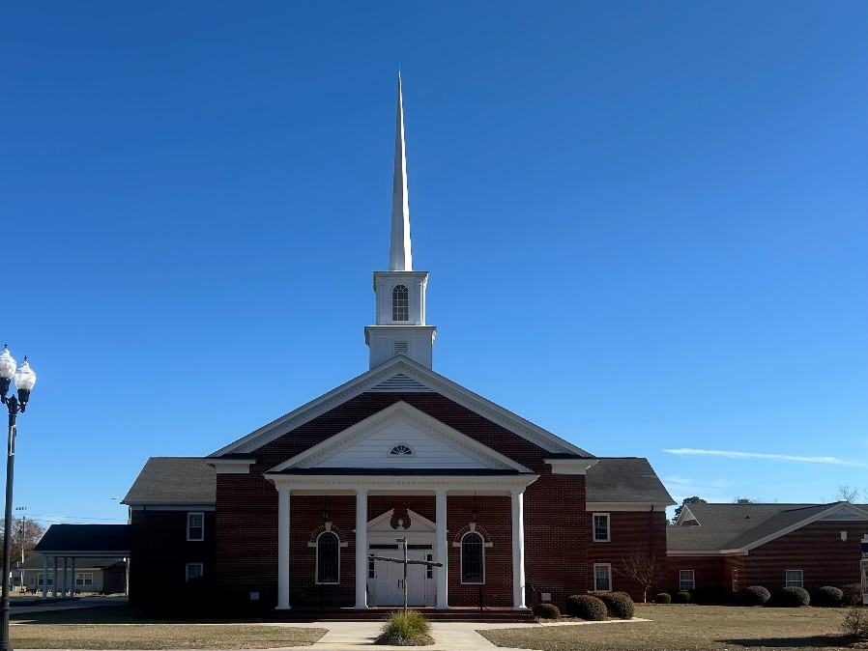

“Until the Whole World Knows”
“Across the Street and Across the Sea – Sent to Sow & Serve”

Our Vision: changing lives by faithfully and intentionally
sharing Christ’s salvation to all the world.

Our Mission …
to reach the lost; to provide spiritual fellowship for the saved; to promote spiritual growth of the saved; and to assist in sending the Gospel of Jesus Christ to the four corners of the earth.

Church Office Telephone: 843-659-2311
Mailing Address: 1642 Main Street, PO Box 233
Turbeville, SC 29162
E-mail Address: TSMChurch@outlook.com
Pastor’s Email: shrum1981@gmail.com
Pastor’s Cell Phone: 573-579-6798
Beth’s Cell Phone: 573-576-7577
Pastor’s Address: 1256 Pope St, Turbeville
Website: tsmc.church

