Making Christ Known
June 28, 2026

Prelude Mrs. Kimberly Newsome
Welcome
Scripture Reading & Prayer
Hymn 112 x2 “Jesus, Name Above All Names”

Hymn 116 “Take the Name of Jesus with You”

Offertory Mrs. Betsy Jordan

Hymn of the Month “How Deep the Father’s Love for Us”

Message Mr. Lane Robinson

Hymn 625 “Doxology”

We welcome our visitors this morning. It is our sincere hope that you feel welcome, that you will be aware of our Lord’s presence, and that you will desire to worship with us again.

The beautiful flowers in the Sanctuary are given to the glory of God by Mrs. Allison Knowlton.

The flag in the front of the sanctuary is to remind us to pray for Graham Newsome who is spending his summer serving on a church planting team in New York City.

Events for the Week
Today Sunday School 10:00 am
Morning Worship 11:00 am
Youth Committee Meeting 4:30 pm
Evening Services (Patriotic Film) 5:30 pm
Monday-Fri Children’s Week @ Camp S & M
Wednesday Bible Studies 6:30 pm

Coming Events
July 4th (Sat) Independence Day
July 5th (Sun) Communion 11:00 am
Installation of Officers 11:00 am
July 7th (Tue) Board of Stewards Organizational Meeting 7:00 pm
July 8th (Wed) Missions Committee Meeting 7:30 pm
July 10th (Fri) Sixty Plus Fellowship @ Becky’s café 11:30 am
July 19th (Sun) Retired Ministers Offering 11:00 am
Youth Committee Meeting 4:30 pm
July 20th (Mon) TWMS in CCLC Building 6:30 pm
District Cartwright @ TSMC 7:00 pm
July 22-24 Eastern Annual Conference in Monroe, NC

Please feel free to call the Pastor for updates.

Prayer Concerns: Taylor Moore, Herbert Mims, Wheeler McCallum, Billy Moore, Keith Jordan, Ruth Watts, April Green, Sarah Timmons, Wallace Green, Riley & Taylor Goff & baby, Scott Beasley, Larry Logan, Rev. Pat Goodwin, Kenny Keels, Richard Clowney, Donnie Green, Dannie Faye Osborne, April Graham, David Jordan, Stephanie & Cierra Carver, Steven Muldrow, Maxie & Sarah Knowlton, Roger Nesbitt, Timmy Thigpen & family, Jeffrey Osborne, Lois Gibbons, Travis Atkinson, Howell Myers, Christine Bryant, Drew Dukes, Joanne McElveen, Johnny McLaughlin, Ann Strickland, Dennis McElveen, Dusty Ward, Anthea Love, Military, family of Mary Frances Green Webster.

Serving as Missionaries: Steve & Beth Coffee, John & Brena Bruner, Rod & Julie Davis, Jimmy & Roxanne Cox, Ray & Paula Yoder.

Shut-Ins & Caregivers: Alan Coker, Larry & Jane Coker, Vera Mae Coker, Randy & Velma Floyd, Stanley Gibbons, Linda Green, Si Green, Carol Ann Griffith, Donna Mae Hardy, Nancy McFaddin, Adam Moore, Carolyn Walker, Roy & Margarite Walker, Mary Lee Wingard, Randy Wingard, Phyllis Yates.

Notes:

______________________________________

______________________________________
____________________________________________________________________________

Turbeville Southern Methodist Church
Rev. Randy Shrum, Pastor

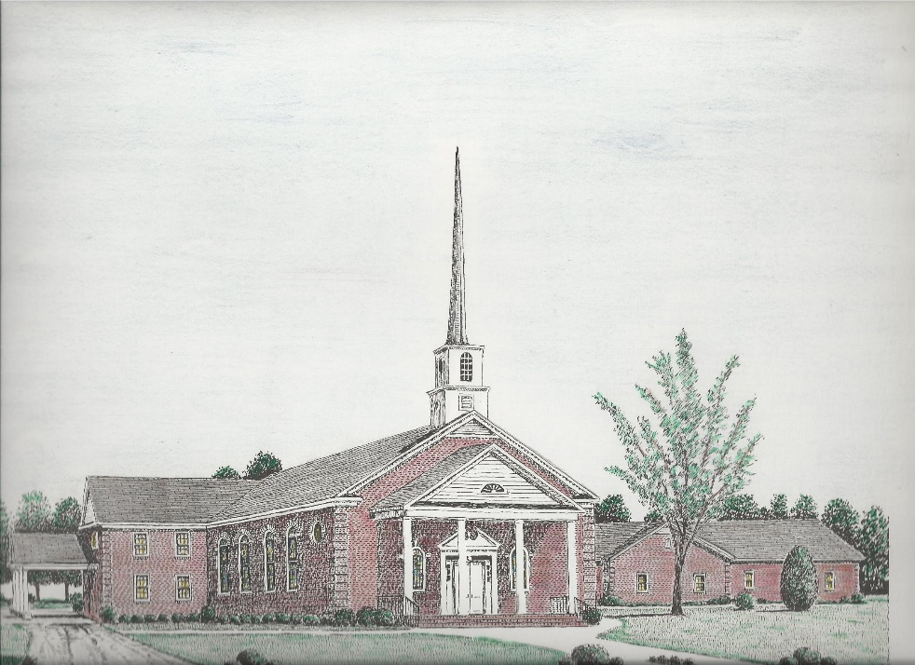

“Until the Whole World Knows”
“Across the Street and Across the Sea – Sent to Sow & Serve”

Our Vision: changing lives by faithfully and intentionally
sharing Christ’s salvation to all the world.

Our Mission …
to reach the lost; to provide spiritual fellowship for the saved; to promote spiritual growth of the saved; and to assist in sending the Gospel of Jesus Christ to the four corners of the earth.

Church Office Telephone: 843-659-2311
Mailing Address: 1642 Main Street, PO Box 233
Turbeville, SC 29162
E-mail Address: TSMChurch@outlook.com
Pastor’s Email: shrum1981@gmail.com
Pastor’s Cell Phone: 573-579-6798
Beth’s Cell Phone: 573-576-7577
Pastor’s Address: 1256 Pope St, Turbeville
Website: tsmc.church

