Making Christ Known
June 14, 2026

Prelude Mrs. Kimberly Newsome
Welcome
Scripture Reading & Prayer
Hymn 508 “I Will Sing the Wondrous Story”

Hymn 494 “Like a River Glorious”

Offertory Mrs. Betsy Jordan

Hymn of the Month “How Deep the Father’s Love for Us”

Message “Self- Confidence or God-Confidence?”
Psalm 91:1-16
Rev. Randy Shrum

Local Conference for Budget & Nominations

Hymn 625 “Doxology”

We welcome our visitors this morning. It is our sincere hope that you feel welcome, that you will be aware of our Lord’s presence, and that you will desire to worship with us again.

The beautiful flowers in the Sanctuary are given to the glory of God by Mrs. Marie Dukes and Miss Lynn Dukes in memory of Mr. & Mrs. Mack Dukes and in honor of Ms. Donna Mae Hardy.

The flag in the front of the sanctuary is to remind us to pray for Graham Newsome who is spending his summer serving on a church planting team in New York City.

Events for the Week
Today Sunday School 10:00 am
Morning Worship 11:00 am
VBS Closing Program 6:00 pm
Monday TWMS in CCLC Building 6:30 pm
Monday-Friday Junior Camp @ Camp S & M
Wednesday Bible Studies 6:30 pm
Friday Sixty Plus Fellowship @ Becky’s Café 11:30 am

Coming Events
June 15-19 Teen Camp @ Camp S & M
June 21st (Sun) Happy Father’s Day! No pm service
June 27th (Sat) 250th birthday of the US program 4:30 pm
June 28th (Sun) Installation of Officers 11:00 am
Youth Committee Meeting 4:30 pm
June 29-July 3 Children’s Week @ Camp S & M

Please feel free to call the Pastor for updates.

Prayer Concerns: Herbert Mims, Billy Moore, Ruth Watts, April Green, Sarah Timmons, Slate Green, Wallace Green, Riley & Taylor Goff & baby, Scott Beasley, Beth Welch, Larry Logan, Rev. Pat Goodwin, Kenny Keels, Richard Clowney, Donnie Green, Dannie Faye Osborne, April Graham, David Jordan, Stephanie & Cierra Carver, Steven Muldrow, Maxie & Sarah Knowlton, Roger Nesbitt, Timmy Thigpen & family, Jeffrey Osborne, Lois Gibbons, Travis Atkinson, Howell Myers, Christine Bryant, Drew Dukes, Joanne McElveen, Johnny McLaughlin, Ann Strickland, Dennis McElveen, Dusty Ward, Anthea Love, Kathryn Turbeville, Military.

Serving as Missionaries: CCLC, Area Pastors and families, Lost in the Community.

Shut-Ins & Caregivers: Alan Coker, Larry & Jane Coker, Vera Mae Coker, Randy & Velma Floyd, Stanley Gibbons, Linda Green, Si Green, Carol Ann Griffith, Donna Mae Hardy, Nancy McFaddin, Adam Moore, Carolyn Walker, Roy & Margarite Walker, Mary Lee Wingard, Randy Wingard, Phyllis Yates.

Notes:

______________________________________

______________________________________
____________________________________________________________________________

Turbeville Southern Methodist Church
Rev. Randy Shrum, Pastor

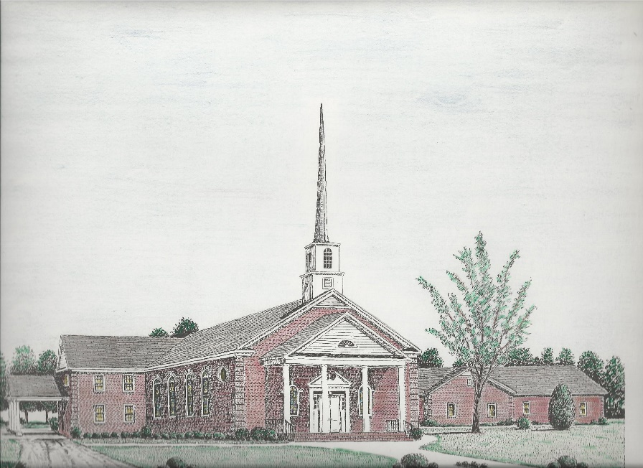

“Until the Whole World Knows”
“Across the Street and Across the Sea – Sent to Sow & Serve”

Our Vision: changing lives by faithfully and intentionally
sharing Christ’s salvation to all the world.

Our Mission …
to reach the lost; to provide spiritual fellowship for the saved; to promote spiritual growth of the saved; and to assist in sending the Gospel of Jesus Christ to the four corners of the earth.

Church Office Telephone: 843-659-2311
Mailing Address: 1642 Main Street, PO Box 233
Turbeville, SC 29162
E-mail Address: TSMChurch@outlook.com
Pastor’s Email: shrum1981@gmail.com
Pastor’s Cell Phone: 573-579-6798
Beth’s Cell Phone: 573-576-7577
Pastor’s Address: 1256 Pope St, Turbeville
Website: tsmc.church

