Making Christ Known
May 31, 2026

Prelude Mrs. Kimberly Newsome
Welcome
Scripture Reading & Prayer
Hymn 350 “”Tis So Sweet to Trust in Jesus”

Hymn 330 “Only Trust Him”

Offertory Mrs. Betsy Jordan

Hymn of the Month “Almost Home”

Message “Serving the Lord Jesus in Every Relationship”
Ephesians 6:5-9
Rev. Randy Shrum

Hymn 625 “Doxology”

The WMS is still accepting donations for the Matron Units. You can place your donation in the bucket on the pulpit or give to Fran Moore or Barbara Goodwin. If you write a check, make it to TWMS and earmark it “Matron Units.”

We welcome our visitors this morning. It is our sincere hope that you feel welcome, that you will be aware of our Lord’s presence, and that you will desire to worship with us again.

The beautiful flowers in the Sanctuary are given to the glory of God by Mrs. April Newsome in loving memory of “Aunt Bert”, Bertie Green.

The flag in the front of the sanctuary is to remind us to pray for Graham Newsome who is spending his summer serving on a church planting team in New York City.

Events for the Week
Today Sunday School 10:00 am
Morning Worship (Benevolent Offering) 11:00 am
Adult Choir Practice 5:00 pm
Graduate Celebration and cookout 6:00 pm
Monday Set-up for VBS 9 am – 7 pm
Tuesday Board of Stewards in Fellowship Hall 7:00 pm
Wednesday Prayer Services 6:30 am
Missions Committee Meeting 7:30 pm
Friday Pickleball Tournament 5:00 pm

Coming Events
June 7-11 VBS 5:30 pm
June 12th (Fri) Sixty Plus Fellowship @ Becky’s Café 11:30 am
June 14th (Sun) Annual Conference for Budget & Nominations 11:00 am
June 15th (Mon) TWMS in CCLC Building 6:30 pm
June 15-19 Teen Camp @ Camp S & M
June 21st (Sun) Happy Father’s Day! No pm service
June 22nd – 26th Junior Week @ Camp S & M
June 27th (Sat) 250th birthday of the US program 4:30 pm
June 28th (Sun) Installation of Officers 11:00 am
Youth Committee Meeting 4:30 pm
June 29-July 3 Children’s Week @ Camp S & M

Please feel free to call the Pastor for updates.

Prayer Concerns: Billy Moore, Ruth Watts, Slate Green, Wallace Green, Riley & Taylor Goff & baby, Scott Beasley, Beth Welch, Larry Logan, Rev. Pat Goodwin,
Barry McCutcheon, Richard Clowney, Donnie Green, Dannie Faye Osborne,
April Graham, David Jordan, Stephanie & Cierra Carver, Steven Muldrow, Maxie & Sarah Knowlton, Roger Nesbitt, Timmy Thigpen & family, Jeffrey Osborne, Danny Atkinson, Lois Gibbons, Travis Atkinson, Howell Myers, Christine Bryant, Drew Dukes, Joanne McElveen, Johnny McLaughlin, Ann Strickland, Dennis McElveen, Dusty Ward, Anthea Love, Katheryn Turbeville, Kenny Keels, Military.

Serving as Missionaries: Gary & Penny Seithel, Yiannakis & Sheri Tittirus, Donna Crane

Shut-Ins & Caregivers: Alan Coker, Larry & Jane Coker, Vera Mae Coker, Randy & Velma Floyd, Stanley Gibbons, Linda Green, Si Green, Carol Ann Griffith, Donna Mae Hardy, Nancy McFaddin, Adam Moore, Carolyn Walker, Roy & Margarite Walker, Mary Lee Wingard, Randy Wingard, Phyllis Yates.

Notes:

______________________________________

______________________________________
____________________________________________________________________________

Turbeville Southern Methodist Church
Rev. Randy Shrum, Pastor

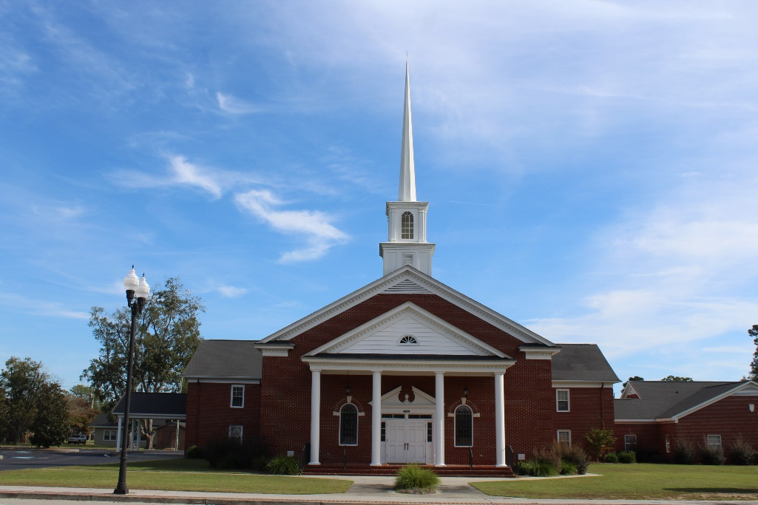

“Until the Whole World Knows”
“Across the Street and Across the Sea – Sent to Sow & Serve”

Our Vision: changing lives by faithfully and intentionally
sharing Christ’s salvation to all the world.

Our Mission …
to reach the lost; to provide spiritual fellowship for the saved; to promote spiritual growth of the saved; and to assist in sending the Gospel of Jesus Christ to the four corners of the earth.

Church Office Telephone: 843-659-2311
Mailing Address: 1642 Main Street, PO Box 233
Turbeville, SC 29162
E-mail Address: TSMChurch@outlook.com
Pastor’s Email: shrum1981@gmail.com
Pastor’s Cell Phone: 573-579-6798
Beth’s Cell Phone: 573-576-7577
Pastor’s Address: 1256 Pope St, Turbeville
Website: tsmc.church

