Making Christ Known
May 3, 2026

Prelude Miss Darcy Newsome
Welcome
Scripture Reading & Prayer
Special Music

Hymn “Jesus Strong and Kind”

Hymn 473 “Victory in Jesus”

Offertory Miss Darcy Newsome

Hymn Behold Our God

Message “Teach Them Diligently”
Deuteronomy 6
Rev. Randy Shrum

Hymn 625 “Doxology”

Graduates

If you are graduating this year, please send your information to our email address (tsmchurch@outlook.com). Graduate Sunday is June 7, 2026. I have Nate Jordan from High School and Maddie Newsome from college.

The beautiful flowers in the Sanctuary are given to the glory of God by Mrs. Frankie Green.

We welcome our visitors this morning. It is our sincere hope that you feel welcome, that you will be aware of our Lord’s presence, and that you will desire to worship with us again.

Events for the Week
Today Sunday School 10:00 am
Morning Worship (Youth Sunday) 11:00 am
Lunch in Fellowship Hall (Mexican) 12:00 pm
Adult Choir Practice 5:00 pm
Evening Worship 6:00 pm
Mon-Thurs General Conference
Tuesday Board of Stewards in Fellowship Hall 7:00 pm
Wednesday WGE Prayer on the Playground 7:30 am
Missions Committee Organizational Meeting 7:30 pm
Thursday National Day of Prayer
Friday Sixty Plus Fellowship @ Becky’s Café 11:30 am

Coming Events
May 10th (Sun) Mother’s Day Brunch in Fellowship Hall 10:00 am
(Evening Services Dismissed)
May 17th (Sun) Youth Committee Meeting 4:30 pm
May 18th (Mon) TWMS in CCLC Building 6:30 pm
Men’s Cartwright Meeting (please sign up) 7:00 pm
May 25th (Mon) Memorial Day
May 31st (Sun) Benevolent Offering

If you are planning on donating to the devotional books, please do so TODAY if possible. THANK YOU to all that have already donated. You can put your donation in the basket on the pulpit marked “Devotion Books.” You may also give your donation to Fran Moore, Barbara Goodwin, or Frankie Green. If you want to write a check, make it out to TWMS and earmark it devotion books.

The WMS BAKE SALE to raise funds for the Matron Units is Saturday. Please be sure to sign up for a sweet in the back hallway TODAY or contact Fran Moore at 843-659-7941 to get on the list. Pick-up will be between 10:00 a.m. and 11:00 a.m. in the Fellowship Hall. We welcome donations without any purchase. Give your donation to Fran Moore or Barbara Goodwin. If you write a check, make it payable to TWMS and earmark it, “Matron Units.”

A special thanks to all who contributed to the success of our revival. Those who prayed faithfully, served diligently, and gave sacrificially, especially those who served our meals each night.

Please feel free to call the Pastor for updates.

Prayer Concerns: Beth Welch, Joan Goldman, Larry Logan, Rev. Pat Goodwin, Barry McCutcheon, Richard Clowney, Donnie Green, Dannie Faye Osborne, April Graham, David Jordan, Stephanie & Ciera Carver, Steven Muldrow, Maxie & Sarah Knowlton, Roger Nesbitt, Timmy Thigpen & family, Jeffrey Osborne, Danny Atkinson, Ruth Watts, Bill Bagnal, Lois Gibbons, Travis Atkinson, Howell Myers, Christine Bryant, Drew Dukes, Joanne McElveen, Johnny McLaughlin, Ann Strickland, Dennis McElveen, Dusty Ward, Anthea Love, Military.

Serving as Missionaries: CCLC; Area Pastors & families; Lost in the community

Shut-Ins & Caregivers: Alan Coker, Larry & Jane Coker, Vera Mae Coker, Randy & Velma Floyd, Stanley Gibbons, Linda Green, Si Green, Carol Ann Griffith, Donna Mae Hardy, Nancy McFaddin, Adam Moore, Barney Lee Morris, Carolyn Walker,
Roy & Margarite Walker, Mary Lee Wingard, Randy Wingard, Phyllis Yates.

Notes:

______________________________________

______________________________________
____________________________________________________________________________

Turbeville Southern Methodist Church
Rev. Randy Shrum, Pastor

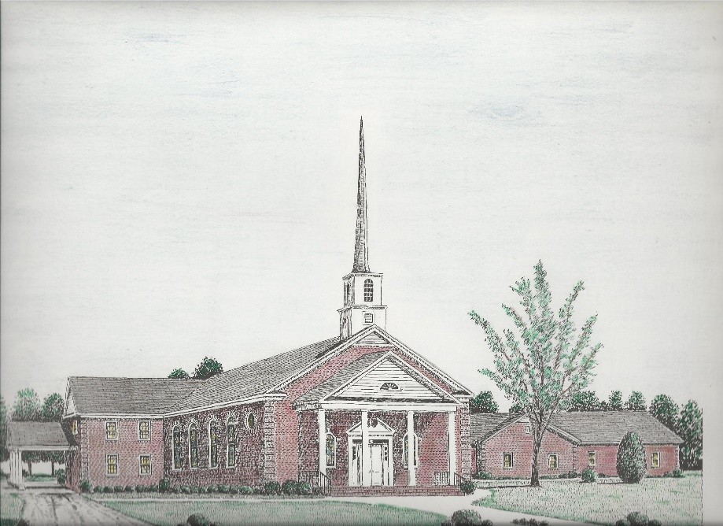

“Until the Whole World Knows”
“Jesus’ Last Command – Our First Priority”

Our Vision: changing lives by faithfully and intentionally
sharing Christ’s salvation to all the world.

Our Mission …
to reach the lost; to provide spiritual fellowship for the saved; to promote spiritual growth of the saved; and to assist in sending the Gospel of Jesus Christ to the four corners of the earth.

Church Office Telephone: 843-659-2311
Mailing Address: 1642 Main Street, PO Box 233
Turbeville, SC 29162
E-mail Address: TSMChurch@outlook.com
Pastor’s Email: shrum1981@gmail.com
Pastor’s Cell Phone: 573-579-6798
Beth’s Cell Phone: 573-576-7577
Pastor’s Address: 1256 Pope St, Turbeville
Website: tsmc.church

