Making Christ Known
April 12, 2026

Prelude Mrs. Betsy Jordan
Welcome
Scripture Reading & Prayer
Hymn 220 “He Lives”

Hymn 210 “Jesus Paid It All”

Song of the Month “Christ the Sure and Steady Anchor”

Offertory Mrs. Kimberly Newsome

Message “This One Thing”
Philippians 2:12-15
Rev. Randy Shrum

Hymn 625 “Doxology”

Congratulations to Bailey & Davis Martin on the birth of their daughter, Eden Wells, born Wednesday, April 8, 2026. Eden weighed 6 lbs 12 oz and was 19.5” long. Congrats also to grandparents, Ellis & Melissa Evans.

Let’s Celebrate Him..
In Honor of Pat Goodwin’s Birthday on 4/11,
We will have a Community-Wide Food Drive for the local food bank. Drop off at our Church, Solid Grounds, Becky’s, Pine Grove or Horse Branch. We can also arrange pickups if needed. Contact with questions.
Melissa Lynch: 803-968-2996
Beth Shrum: 573-576-7577
Kat Coker: 803-460-6194
Lucia Coker: 803-460-6192
Mary Ashley Turner : 843-373-7921
We welcome our visitors this morning. It is our sincere hope that you feel welcome, that you will be aware of our Lord’s presence, and that you will desire to worship with us again.

The beautiful flowers are placed in the Sanctuary for the glory of God by Mrs. Velma Floyd.

Events for the Week
Today Prayer Time 9:30 am
Sunday School 10:00 am
Morning Worship 11:00 am
Adult Choir Practice 5:00 pm
Evening Services 6:00 pm
Wednesday Prayer Services 6:30 pm
Fri-Sun Puddin Swamp Festival

Coming Events
Apr. 19th (Sun) Gideon Sunday 11:00 am
Youth Committee Meeting 4:30 pm
Apr. 20th (Mon) TWMS Meeting in CCLC Building 6:30 pm
District Men’s Cartwright @ Philadelphia 7:00 pm
Apr. 20-30 Sumter Crusade
Apr. 24-25 Camp S & M Spring Work Days 8:30 am
Apr. 26th (Sun) Church Conference for Pastor 11:00 am
Apr. 26-29 Revival with Rev. Donnie Miles

Camp S & M Workdays: April 24 & 25: 8:30-lunch. Join for 1 day or both. Bring brooms, pressure washers, yard tools, gloves, weedeaters, and step stools. Lunch, snacks and drinks provided. Contact Deborah Westbury at 843-560-1890. RSVP by April 19th.

The TSMC Missions Team will have a food booth at the Puddin Swamp Festival on Friday, Saturday and Sunday (1pm-6-m). Come show your support.

The WMS is asking for donations to help purchase Devotion Books for the campers who will be attending Camp S & M and Three-Forks Trail this summer. We want every camper to have an age-appropriate devotion book they can carry home that will help them in their walk with the Lord. The cost last year was over $800 and we hope to raise enough money to fund these books for the campers. You may put your donation in the bucket marked “Devotion Books” or give it to Fran Moore or Frankie Green. Make your checks payable to TWMS.

Church, we are in desperate need of revival. Not a series of meetings, but a sovereign outpouring of the power of God! Let’s set aside time to fast and pray for revival – God’s power is waiting to move in our hearts. I’m pledging to pray at least twice daily just for revival. We will gather together for prayer every evening until revival at 7:30 pm at the altar. Join me!

Please feel free to call the Pastor for updates.

Prayer Concerns: Larry Logan, Rev. Pat Goodwin, Barry McCutcheon, Richard Clowney, Glen Mitchum, Donnie Green, Dannie Faye Osborne, April Graham, David Jordan, Stephanie & Ciera Carver, Steven Muldrow, Maxie & Sarah Knowlton, Roger Nesbitt, Timmy Thigpen & family, Jeffrey Osborne, Danny Atkinson, Ruth Watts, Bill Bagnal, Lois Gibbons, Travis Atkinson, Howell Myers, Christine Bryant, Keri Passot, Donna Breighner, Charles Dinkins, Drew Dukes, Joanne McElveen, Johnny McLaughlin, Ann Strickland, Dennis McElveen, Dusty Ward, Anthea Love, Military.

Serving as Missionaries: Steve & Anthea Love, Chris & Tami Harbin, Sam & Liz Bruner

Shut-Ins & Caregivers: Alan Coker, Larry & Jane Coker, Vera Mae Coker, Randy & Velma Floyd, Stanley Gibbons, Linda Green, Si Green, Carol Ann Griffith, Donna Mae Hardy, Nancy McFaddin, Adam Moore, Barney Lee Morris, Carolyn Walker,
Roy & Margarite Walker, Mary Lee Wingard, Randy Wingard, Phyllis Yates.

Notes:

______________________________________

______________________________________
____________________________________________________________________________

Turbeville Southern Methodist Church
Rev. Randy Shrum, Pastor

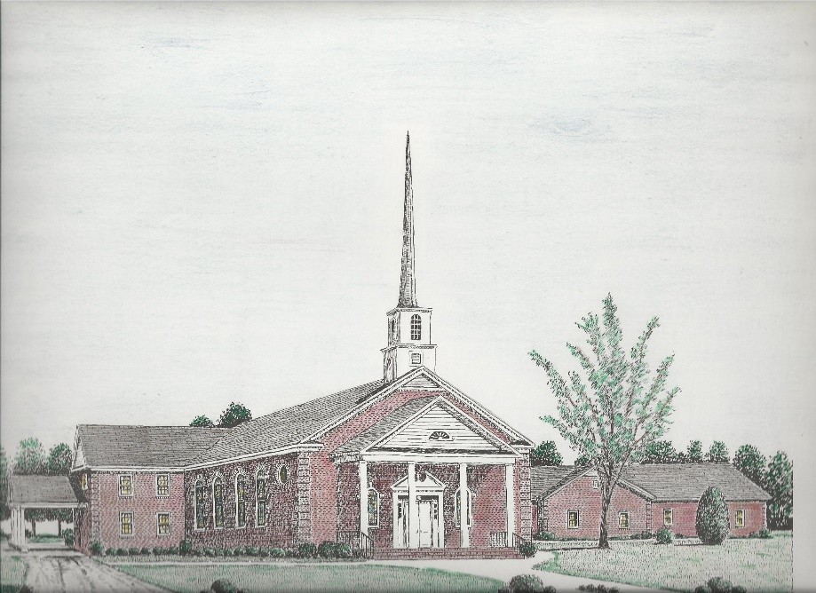

“Until the Whole World Knows”
“Jesus’ Last Command – Our First Priority”

Our Vision: changing lives by faithfully and intentionally
sharing Christ’s salvation to all the world.

Our Mission …
to reach the lost; to provide spiritual fellowship for the saved; to promote spiritual growth of the saved; and to assist in sending the Gospel of Jesus Christ to the four corners of the earth.

Church Office Telephone: 843-659-2311
Mailing Address: 1642 Main Street, PO Box 233
Turbeville, SC 29162
E-mail Address: TSMChurch@outlook.com
Pastor’s Email: shrum1981@gmail.com
Pastor’s Cell Phone: 573-579-6798
Beth’s Cell Phone: 573-576-7577
Pastor’s Address: 1256 Pope St, Turbeville
Website: tsmc.church

