Making Christ Known
March 22, 2026

Prelude Mrs. Kimberly Newsome
Welcome
Scripture Reading & Prayer
Hymn 196 “There Is a Fountain”

Hymn “Behold Our God”

Offertory Mrs. Betsy Jordan

Special Music Adult Choir

Song of the Month “Christ is Risen, He Is Risen Indeed”

Message “Submitting Yourselves”
Ephesians 5:17-21
Rev. Randy Shrum

Hymn 625 “Doxology”

We are trying to get a “texting system” implemented. I need your cell number. Please don’t assume I have yours; our system could be outdated. This is mostly for emergency times when we have to change service times, etc. No Long Texts! Please send me your cell numbers to tsmchurch@outlook.com.

We welcome our visitors this morning. It is our sincere hope that you feel welcome, that you will be aware of our Lord’s presence, and that you will desire to worship with us again.

The beautiful flowers are placed in the Sanctuary for the glory of God by Ms. Mary Lee Wingard and Mrs. Mary Dee Youngblood in memory of Mr. J.D. Wingard.

Events for the Week
Today Prayer Time 9:30 am
Sunday School 10:00 am
Morning Worship 11:00 am
Adult Choir Practice 5:00 pm
Evening Services 6:00 pm
Monday TWMS in the CCLC Building 6:30 pm
Wednesday Prayer Services 6:30 pm

Coming Events
Mar. 29th (Sun) Benevolent Offering 11:00 am
Palm Sunday Offering for Camps 11:00 am
April 3rd (Fri) Good Friday
April 5th (Sun) Easter Sunday
Apr. 6-10 Spring Break Trip to Merritt Island
Apr. 7th (Tue) Board of Stewards in Fellowship Hall 7:00 pm
Apr. 8th (Wed) Missions Committee Meeting 7:30 pm
Apr. 10th (Fri) Sixty Plus Fellowship @ Becky’s Café 11:30 am
Apr. 16-18 Puddin Swamp Festival
Apr. 19th (Sun) Youth Committee Meeting 4:30 pm
Apr. 20th (Mon) TWMS Meeting in CCLC Building 6:30 pm
Apr. 20-30 Sumter Crusade
Apr. 24-25 Camp S & M Spring Work Days 8:30 am
Apr. 26th (Sun) Church Conference for Pastor 11:00 am
Apr. 26-29 Revival with Rev. Donnie Miles

Camp S & M Workdays: April 24 & 25: 8:30-lunch. Join for 1 day or both. Bring brooms, pressure washers, yard tools, gloves, weedeaters, and step stools. Lunch, snacks and drinks provided. Contact Deborah Westbury at 843-560-1890. RSVP by April 19th.

Please feel free to call the Pastor for updates.

Prayer Concerns: Larry Logan, Rev. Pat Goodwin, Micayla Jackson, Barry McCutcheon, Earl Glover, Mark Shores (Randy’s bil), Richard Clowney, Roy Walker, Glen Mitchum, Donnie Green, Justin Evans, Jason Sellers, Dannie Faye Osborne, April Graham, Millie Sims, Chad Bartlett, David Jordan, Ginger Keels, Judy Hall, Stephanie & Ciera Carver, Debbie Wall, Steven Muldrow, Stephanie Miles, Maxie & Sarah Knowlton, Roger Nesbitt, Timmy Thigpen & family, Jeffrey Osborne, Danny Atkinson, Ruth Watts, Bill Bagnal, Lois Gibbons, Travis Atkinson, Howell Myers, Christine Bryant, Keri Passot, Donna Breighner, Charles Dinkins, Drew Dukes, Joanne McElveen, Johnny McLaughlin, Ann Strickland, Dennis McElveen, Military, Dusty Ward, family of Doug Robinson, family of Tony McLaughlin, family of David Malone.

Serving as Missionaries: Steve & Beth Coffee, John & Brena Bruner, Rod & Julie Davis, Jimmy & Roxanne Cox, Ray & Paula Yoder.

Shut-Ins & Caregivers: Alan Coker, Larry & Jane Coker, Vera Mae Coker, Randy & Velma Floyd, Stanley Gibbons, Linda Green, Si Green, Carol Ann Griffith, Donna Mae Hardy, Nancy McFaddin, Adam Moore, Barney Lee Morris, Carolyn Walker,
Roy & Margarite Walker, Mary Lee Wingard, Randy Wingard, Phyllis Yates.

Notes:

______________________________________

______________________________________
______________________________________
______________________________________
______________________________________
____________________________________________________________________________

Turbeville Southern Methodist Church
Rev. Randy Shrum, Pastor

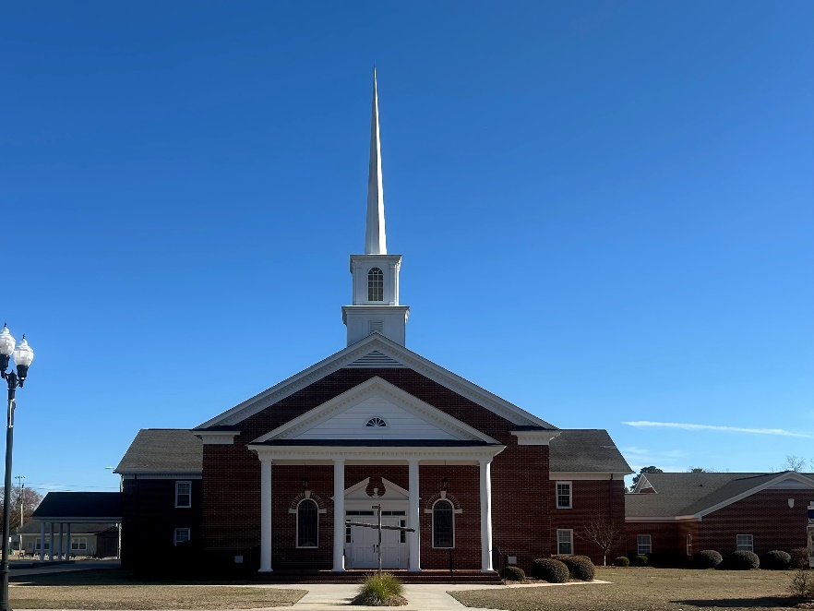

“Until the Whole World Knows”
“Jesus’ Last Command – Our First Priority”

Our Vision: changing lives by faithfully and intentionally
sharing Christ’s salvation to all the world.

Our Mission …
to reach the lost; to provide spiritual fellowship for the saved; to promote spiritual growth of the saved; and to assist in sending the Gospel of Jesus Christ to the four corners of the earth.

Church Office Telephone: 843-659-2311
Mailing Address: 1642 Main Street, PO Box 233
Turbeville, SC 29162
E-mail Address: TSMChurch@outlook.com
Pastor’s Email: shrum1981@gmail.com
Pastor’s Cell Phone: 573-579-6798
Beth’s Cell Phone: 573-576-7577
Pastor’s Address: 1256 Pope St, Turbeville
Website: tsmc.church

