Making Christ Known
March 15, 2026

Prelude Mrs. Betsy Jordan
Welcome
Scripture Reading & Prayer
Hymn 297 “I Love to Tell the Story”

Hymn 296 “We’ve a Story to Tell to the Nations”

Song of the Month “Christ is Risen, He Is Risen Indeed”

Offertory Mrs. Kimberly Newsome

Special Music Mrs. Amy Glover

Message Dale & LyNan Redman

Hymn 625 “Doxology”

We welcome our visitors this morning. It is our sincere hope that you feel welcome, that you will be aware of our Lord’s presence, and that you will desire to worship with us again.

Events for the Week
Today Prayer Time 9:30 am
Sunday School 10:00 am
Morning Worship 11:00 am
Youth Committee Meeting 4:30 pm
Adult Choir Practice 5:00 pm
Evening Services (Ray & Paula Yoder) 6:00 pm
Monday TWMS in the CCLC Building 6:30 pm
Wednesday Prayer Services 6:30 pm

Coming Events
Mar. 29th (Sun) Benevolent Offering 11:00 am
Palm Sunday Offering for Camps 11:00 am
April 5th (Sun) Easter Sunday
Apr. 6-10 Spring Break Trip to Merritt Island
Apr. 7th (Tue) Board of Stewards in Fellowship Hall 7:00 pm
Apr. 8th (Wed) Missions Committee Meeting 7:30 pm
Apr. 10th (Fri) Sixty Plus Fellowship @ Becky’s Café 11:30 am
Apr. 16-18 Puddin Swamp Festival
Apr. 19th (Sun) Youth Committee Meeting 4:30 pm
Apr. 20th (Sun) TWMS Meeting in CCLC Building 6:30 pm
Apr. 20-30 Sumter Crusade
Apr. 26th (Sun) Church Conference for Pastor 11:00 am
Apr. 26-29 Revival with Rev. Donnie Miles

Please feel free to call the Pastor for updates.

Prayer Concerns: Doug Robinson, David Malone, Kelli Grant, Larry Logan, Gracielynn McCallum, Rev. Pat Goodwin, Micayla Jackson, Barry McCutcheon, Earl Glover, Mary Watts, Mark Shores (Randy’s bil), Richard Clowney, Roy Walker, Glen Mitchum, Donnie Green, Justin Evans, Jason Sellers, Dannie Faye Osborne, April Graham, Millie Sims, Chad Bartlett, David Jordan, Ginger Keels, Judy Hall, Stephanie & Ciera Carver, Debbie Wall, Steven Muldrow, Stephanie Miles, Maxie & Sarah Knowlton, Roger Nesbitt, Timmy Thigpen & family, Jeffrey Osborne, Danny Atkinson, Ruth Watts, Bill Bagnal, Lois Gibbons, Travis Atkinson, Howell Myers, Christine Bryant, Keri Passot, Donna Breighner, Charles Dinkins, Drew Dukes, Joanne McElveen, Johnny McLaughlin, Tony McLaughlin, Ann Strickland, Dennis McElveen, Military, Dusty Ward, family of Clay Coker, the Williamson family.

Serving as Missionaries: Teen Missions International, Trey & Mary Watts, Brant & Mary Lane, Steve & Gay Petersen, Rodney & Teresa Walls, Dale & LyNan Redman.

Shut-Ins & Caregivers: Alan Coker, Larry & Jane Coker, Vera Mae Coker, Randy & Velma Floyd, Stanley Gibbons, Linda Green, Si Green, Carol Ann Griffith, Donna Mae Hardy, Nancy McFaddin, Adam Moore, Barney Lee Morris, Carolyn Walker,
Roy & Margarite Walker, Mary Lee Wingard, Randy Wingard, Phyllis Yates.

Notes:

______________________________________

______________________________________
______________________________________
______________________________________
______________________________________
____________________________________________________________________________

Turbeville Southern Methodist Church
Rev. Randy Shrum, Pastor

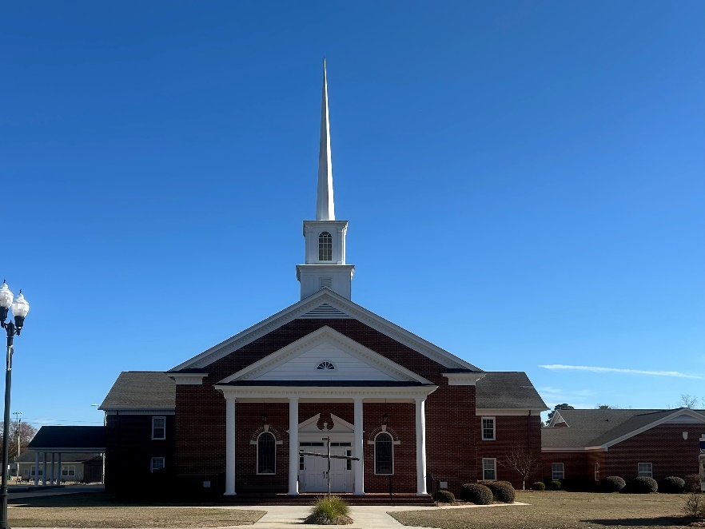

“Until the Whole World Knows”
“Jesus’ Last Command – Our First Priority”

Our Vision: changing lives by faithfully and intentionally
sharing Christ’s salvation to all the world.

Our Mission …
to reach the lost; to provide spiritual fellowship for the saved; to promote spiritual growth of the saved; and to assist in sending the Gospel of Jesus Christ to the four corners of the earth.

Church Office Telephone: 843-659-2311
Mailing Address: 1642 Main Street, PO Box 233
Turbeville, SC 29162
E-mail Address: TSMChurch@outlook.com
Pastor’s Email: shrum1981@gmail.com
Pastor’s Cell Phone: 573-579-6798
Beth’s Cell Phone: 573-576-7577
Pastor’s Address: 1256 Pope St, Turbeville
Website: tsmc.church

