Making Christ Known
March 1, 2026

Prelude Mrs. Betsy Jordan
Welcome
Scripture Reading & Prayer
Hymn “I Can Not Tell It All”

Hymn 470 “Footsteps of Jesus”

Hymn 471 “The Way of the Cross Leads Home”

Offertory Mrs. Kimberly Newsome

Message “Stepping in the Light”
Ephesians 5:6-17 Rev. Randy Shrum

Hymn 625 “Doxology”

We welcome our visitors this morning. It is our sincere hope that you feel welcome, that you will be aware of our Lord’s presence, and that you will desire to worship with us again.

The beautiful flowers are placed in the Sanctuary for the glory of God by Mrs. Jan Baxley in memory of Mrs. Gail Baxley.

Events for the Week
Today Prayer Time 9:30 am
Sunday School 10:00 am
Morning Worship 11:00 am
Music Committee Meeting 5:00 pm
Adult Choir Practice 5:00 pm
Evening Services 6:00 pm
Tuesday Board of Stewards in Fellowship Hall 7:00 pm
Wednesday Prayer on the Playground 7:30 pm
Prayer Services 6:30 pm
Missions Committee Meeting 7:30 pm
Fri-Sun Teen Retreat @ Camp S & M

Coming Events
March 8th (Sun)Daylight Savings Time Begins 2:00 am
Acorn Breaking 10:00 am
Local Conference for Nominations 11:00 am
Mar. 13th (Fri) Sixty Plus Fellowship @ Becky’s 11:30 am
Mar. 13-15 Missions Conference – Mark Your Calendars
Mar. 15th (Sun) Youth Committee Meeting 4:30 pm
Mar. 16th (Mon) TMWS in CCLC Building 6:30 pm
Mar. 29th (Sun) Benevolent Offering 11:00 am
Palm Sunday Offering for Camps 11:00 am

Teen Missions Spring Break Trip is April 6-11. Applications are in the hall. Must be submitted by March 2nd.

Please feel free to call the Pastor for updates.

Prayer Concerns: Barry McCutcheon, Earl Glover, Mary Watts, Mark Shores (Randy’s bil), Richard Clowney, Roy Walker, Laura Kelly, Glen Mitchum, Donnie Green, Justin Evans, Jason Sellers, Dannie Faye Osborne, April Graham, Millie Sims, Chad Bartlett, David Jordan, Ginger Keels, Judy Hall, Stephanie & Ciera Carver, Debbie Wall, Steven Muldrow, Stephanie Miles, Maxie & Sarah Knowlton, Micayla Jackson, Timmy Thigpen & family, Jeffrey Osborne, Danny Atkinson, Ruth Watts, Bill Bagnal, Lois Gibbons, Travis Atkinson, Howell Myers, Christine Bryant, Keri Passot, Donna Breighner, Charles Dinkins, Drew Dukes, Joanne McElveen, Johnny McLaughlin, Tony McLaughlin, Ann Strickland, Dennis McElveen, Military, Dusty Ward, family of Joann Wallace, family of Rebecca Coker Thies.

Serving as Missionaries: CCLC, Area Pastors & families, Lost in the Community

Shut-Ins & Caregivers: Alan Coker, Larry & Jane Coker, Vera Mae Coker, Randy & Velma Floyd, Stanley Gibbons, Linda Green, Si Green, Carol Ann Griffith, Donna Mae Hardy, Nancy McFaddin, Adam Moore, Barney Lee Morris, Carolyn Walker,
Roy & Margarite Walker, Mary Lee Wingard, Randy Wingard, Phyllis Yates.

Notes:

______________________________________

______________________________________
______________________________________
______________________________________
______________________________________
____________________________________________________________________________

Turbeville Southern Methodist Church
Rev. Randy Shrum, Pastor

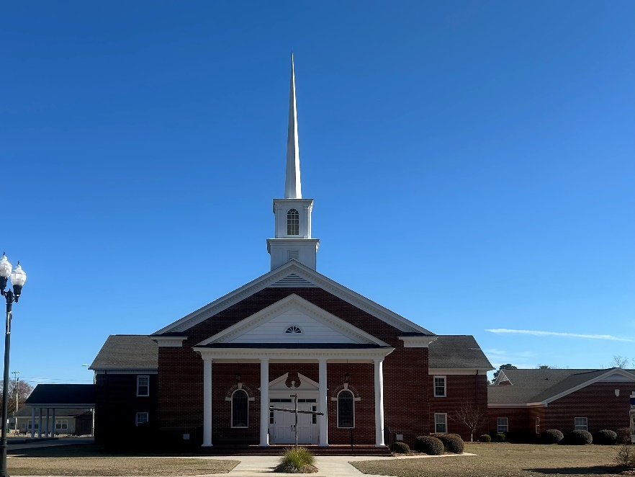

“Until the Whole World Knows”
“Jesus’ Last Command – Our First Priority”

Our Vision: changing lives by faithfully and intentionally
sharing Christ’s salvation to all the world.

Our Mission …
to reach the lost; to provide spiritual fellowship for the saved; to promote spiritual growth of the saved; and to assist in sending the Gospel of Jesus Christ to the four corners of the earth.

Church Office Telephone: 843-659-2311
Mailing Address: 1642 Main Street, PO Box 233
Turbeville, SC 29162
E-mail Address: TSMChurch@outlook.com
Pastor’s Email: shrum1981@gmail.com
Pastor’s Cell Phone: 573-579-6798
Beth’s Cell Phone: 573-576-7577
Pastor’s Address: 1256 Pope St, Turbeville
Website: tsmc.church

