Making Christ Known
February 8, 2026

Prelude Mrs. Kimberly Newsome
Scripture Reading & Prayer
Hymn 18 “Come, We That Love the Lord”

Hymn “Yet Not I But Christ in Me”

Song for the month “Here is Love, Vast as the Ocean”

Offertory Mrs. Betsy Jordan

Hymn 505 “Love Lifted Me”

Message “Walking Worthy”
Ephesians 4:11-16 Rev. Randy Shrum

Hymn 625 “Doxology”

We welcome our visitors this morning. It is our sincere hope that you feel welcome, that you will be aware of our Lord’s presence, and that you will desire to worship with us again.

The beautiful flowers are placed in the Sanctuary for the glory of God by Mrs. Yvonne Hodge in memory of Mrs. Dianne Coker.

Events for the Week
Today Prayer Time 9:30 am
Sunday School 10:00 am
Morning Worship (Green Endowment Fund) 11:00 am
Adult Choir Practice 5:00 pm
Evening Services 6:00 pm
Wednesday Prayer Services 6:30 pm
Thursday Ruritan Pancake Supper @ Becky’s 5:30-7:30 pm
Friday Sixty Plus Fellowship @ Becky’s 11:30 am
Saturday Valentine’s Day Parade for TC Home 11:00 am

Coming Events
Feb. 15th (Sun) Youth Committee Meeting 7:00 pm
Feb. 17th (Tue) Annual Fellowship Dinner @ SM College 6:30 pm
Mar. 13-15 Missions Conference – Mark Your Calendars

We are in the process of upgrading to a texting system. We need your cell phone number to put in our system. Please send name and number to our email at tsmchurch@outlook.com.

Please feel free to call the Pastor for updates.

Prayer Concerns: Donnie Green, Justin Evans, Jason Sellers, Dannie Faye Osborne, April Graham, Millie Sims, Laura Kelly, Chad Bartlett, David Jordan, Ginger Keels, Judy Hall, Stephanie & Ciera Carver, Debbie Wall, Steven Muldrow, Stephanie Miles, Maxie & Sarah Knowlton, Marvin Ward, Joann Wallace, Micayla Jackson, Timmy Thigpen & family, Jeffrey Osborne, Danny Atkinson, Ruth Watts, Bill Bagnal, Lois Gibbons, Travis Atkinson, Howell Myers, Christine Bryant, Keri Passot, Donna Breighner, Charles Dinkins, Drew Dukes, Joanne McElveen, Johnny McLaughlin, Tony McLaughlin, Ann Strickland, Dennis McElveen, Military, family of Beau Coker, family of Dana Kinlaw.

Serving as Missionaries: Gary & Penny Siethel, Yiannakis & Sheri Tittirus,
Donna Crane.

Shut-Ins & Caregivers: Alan Coker, Larry & Jane Coker, Vera Mae Coker, Randy & Velma Floyd, Stanley Gibbons, Linda Green, Si Green, Carol Ann Griffith, Donna Mae Hardy, Nancy McFaddin, Adam Moore, Barney Lee Morris, Carolyn Walker,
Roy & Margarite Walker, Mary Lee Wingard, Randy Wingard, Phyllis Yates.

Notes:

______________________________________

______________________________________
______________________________________
______________________________________
______________________________________
____________________________________________________________________________

Turbeville Southern Methodist Church
Rev. Randy Shrum, Pastor

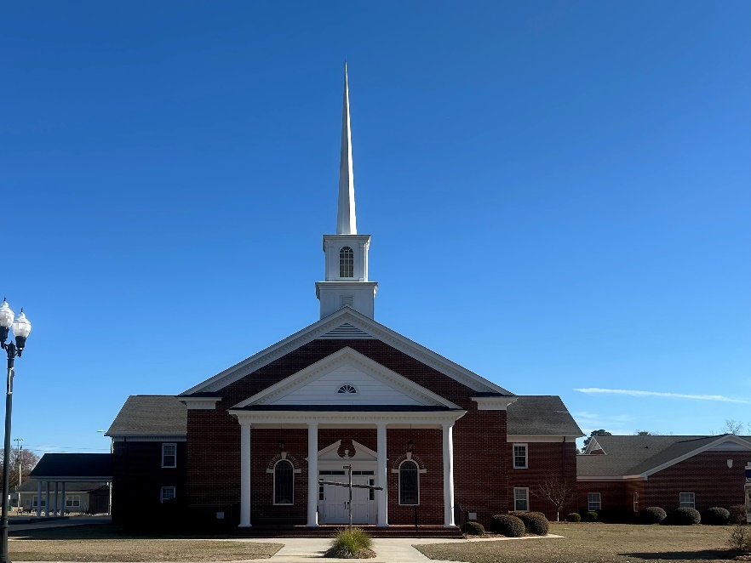

“Until the Whole World Knows”
“Jesus’ Last Command – Our First Priority”

Our Vision: changing lives by faithfully and intentionally
sharing Christ’s salvation to all the world.

Our Mission …
to reach the lost; to provide spiritual fellowship for the saved; to promote spiritual growth of the saved; and to assist in sending the Gospel of Jesus Christ to the four corners of the earth.

Church Office Telephone: 843-659-2311
Mailing Address: 1642 Main Street, PO Box 233
Turbeville, SC 29162
E-mail Address : TSMChurch@outlook.com
Pastor’s Email: shrum1981@gmail.com
Pastor’s Cell Phone: 573-579-6798
Beth’s Cell Phone: 573-576-7577
Pastor’s Address: 1256 Pope St, Turbeville

